Name: Saurabh Mukherjee Roll no: 001910501006 Class: BCSE II Sem: First Session 2020-21

Assignment Set :1

Problem No. 1

Problem Statement :

Write a program to compute the factorial of an integer *n* iteratively and recursively. Check when there is overflow in the result and change the data types for accommodating higher values of inputs.

Solution Approach:

Iterative Approach:

The factorial has been initially initialised to 1 .The for loop runs till n and each time factorial gets updated to (factorial\*i) , where i is the value of the loop counter. As a result when the loop gets terminated for the value of n+1, we have factorial as our answer.

Recursive Approach:

The recursive approach has base case when n=1 , factorial=1,else it calculates factorial(n-1) using the concept of recursion and then multiplies it with n that is n\*factorial(n-1) to get the desired result.

Overflow Check:

In both the above cases the overflow is checked by continuously incrementing the values of n and finding the first mismatch of the factorial result with that obtained from our program.

Structured Pseudocode :

Iterative Approach

Factorial(n)

1.factorial=1

2.For i from 1 to n:

3. factorial=factorial \*i

4.return factorial

Recursive Approach:

Factorial(n)

1.if n==1

2. return 1

3.return n\*Factorial(n-1)

Results:

The results obtained from both of the above approaches depends on the data-type we are selecting for the return value of the factorial function.The program is failing to give correct results at 13 when the data type used is int and at 21 when the data type is long or long long int.This is the clip of the program to show that the program fails at 21 and after it.

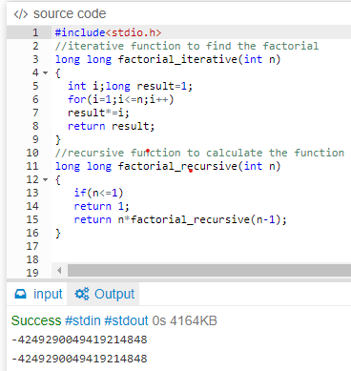

Discussion:

Here, the iterative procedure is relatively better in terms of the calculation of factorial as in the recursive approach we have the overhead of the function calls and each time the function is called it gets pushed to the system stack and then again after reaching the base case gets popped and the value gets substituted for the popped function.

Separate files containing commented source code

The file has been attached.